Advanced flows
In addition to basic payments “flows” supported out of the box, it’s also possible to create your own “advanced flows” using various non-payment transactions like building blocks either before or after a payment. Below are a few examples of what’s possible.

Payment type selection
It’s common for a POS system with customer facing terminal(s) to use that equipment to allow the customer to select their preferred method of payment. For merchants accepting certain payment types, like EBT, it may be a requirement of the EBT program.
This can be done ahead of an <EMVSale> using the <GetMultipleChoice> TranCode, which enables the POS to display a prompt with up to 6 choices (dependent on device model) to the customer.
The following is an example of a “Payment selection” prompt and the request used to display it.
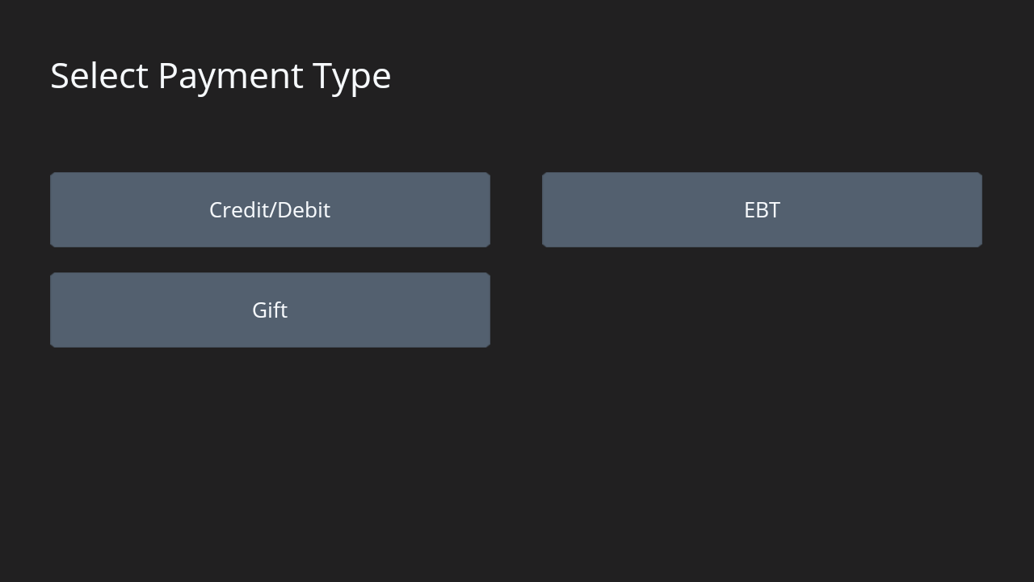
Request
- xml
- json
POST /ProcessEMVTransaction/ HTTP/1.1
Host: 192.168.1.232:8080
Content-Type: application/xml
Content-Length: 235

<?xml version="1.0"?>
<TStream>
<Transaction>
<Prompt>Select Payment Type</Prompt>
<SecureDevice>CloudEMV2</SecureDevice>
<SequenceNo>0010010010</SequenceNo>
<TranCode>GetMultipleChoice</TranCode>
<ButtonData>Credit/Debit,EBT,Gift</ButtonData>
<POSPackageID>POSName:1.2.3</POSPackageID>
<MerchantID>DEMODCHALGP</MerchantID>
</Transaction>
</TStream>
When the customer makes their selection, a response with <CmdStatus> “Success” is returned along with a <GetMultipleChoiceResponse> containing the text of the selected button. In this case the customer selected “Credit / Debit”.
Response
- xml
- json
<?xml version="1.0" encoding="UTF-8"?>
<RStream>
<ResponseOrigin>Client</ResponseOrigin>
<DSIXReturnCode>000000</DSIXReturnCode>
<CmdStatus>Success</CmdStatus>
<TextResponse>Success</TextResponse>
<SequenceNo>0010010010</SequenceNo>
<TranCode>GetMultipleChoice</TranCode>
<GetMultipleChoiceResponse>Credit/Debit </GetMultipleChoiceResponse>
</RStream>

EBT Menus
It’s also possible to combine multiple “menus” or “payment type selections” together. For example, EBT programs frequently consist of multiple types of benefits. The POS needs to be aware of these benefit types and ensure items are qualified and properly indicated by a specific EBT type.
For this use case, the POS can send an additional <GetMultipleChoice> request when the EBT button is selected, allowing the customer to select the EBT benefit type.
 | 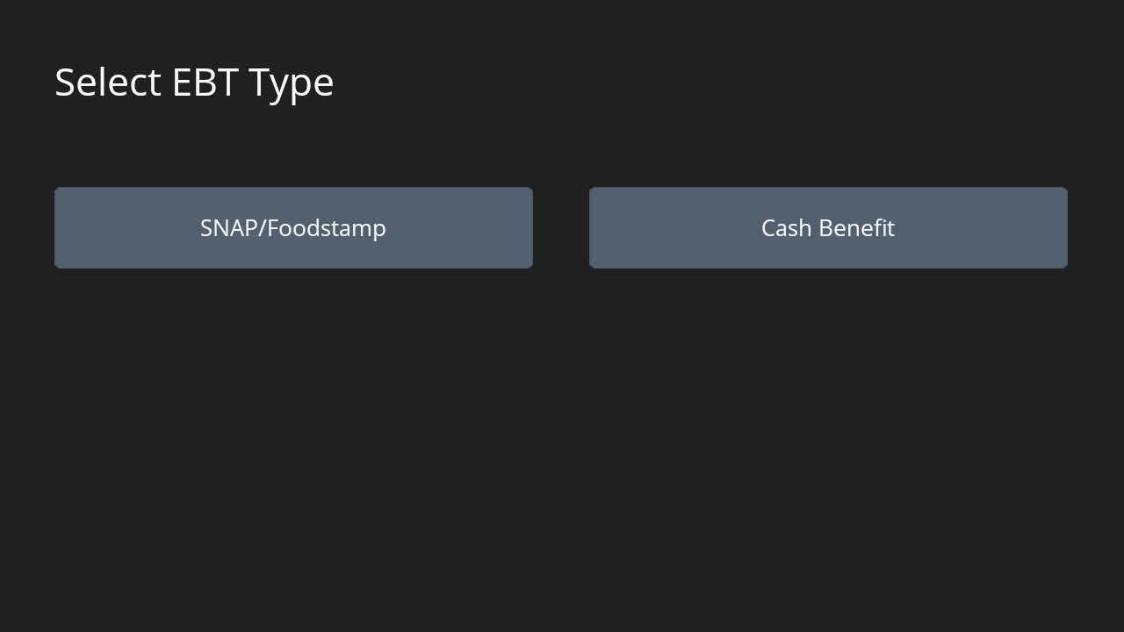
Select Payment Type | Select EBT Type
Response from “EBT” selection
- xml
- json
<?xml version="1.0"?>
<RStream>
<ResponseOrigin>Client</ResponseOrigin>
<DSIXReturnCode>000000</DSIXReturnCode>
<CmdStatus>Success</CmdStatus>
<TextResponse>Success</TextResponse>
<SequenceNo>0010010010</SequenceNo>
<TranCode>GetMultipleChoice</TranCode>
<GetMultipleChoiceResponse>EBT </GetMultipleChoiceResponse>
</RStream>
Follow-up Request
- xml
- json
POST /ProcessEMVTransaction/ HTTP/1.1
Host: 192.168.1.232:8080
Content-Type: application/xml
Content-Length: 264

<?xml version="1.0"?>
<TStream>
<Transaction>
<MerchantID>DEMODCHALGP</MerchantID>
<POSPackageID>POSName:1.2.3</POSPackageID>
<TranCode>GetMultipleChoice</TranCode>
<SecureDevice>CloudEMV2</SecureDevice>
<SequenceNo>0010010010</SequenceNo>
<Prompt>Select EBT Type</Prompt>
<ButtonData>SNAP / Foodstamp,Cash Benefit</ButtonData>
</Transaction>
</TStream>
Response
- xml
- json
<?xml version="1.0" encoding="UTF-8"?>
<RStream>
<ResponseOrigin>Client</ResponseOrigin>
<DSIXReturnCode>000000</DSIXReturnCode>
<CmdStatus>Success</CmdStatus>
<TextResponse>Success</TextResponse>
<SequenceNo>0010010010</SequenceNo>
<TranCode>GetMultipleChoice</TranCode>
<GetMultipleChoiceResponse>SNAP / Foodstamp</GetMultipleChoiceResponse>
</RStream>


